بسمه تعالی
فرم چکیده سخنرانی ژورنال کلاب دانشجویان دکترا ورودی
دانشکده بهداشت – گروه مهندسی بهداشت محیط

نام و نام خانوادگی دانشجو : زهره بهمنی
شماره دانشجویی: 9711150005 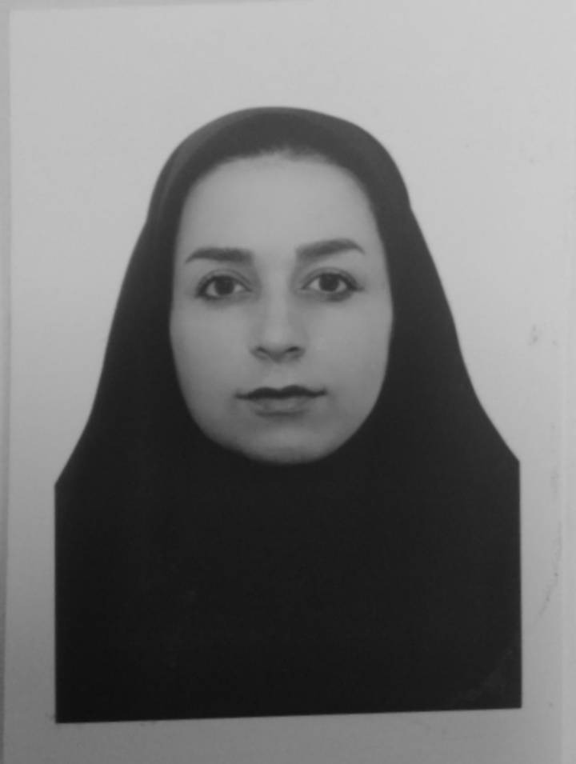

استاد راهنمای آموزشی: جناب آقای دکتریونسیان عکس دانشجو:
تاریخ : 05/12/1399 ساعت: 15
عنوان مقاله :
Transmission of COVID-19 virus by droplets and aerosols: A critical review on the unresolved dichotomy
چکیده : 150لغت

The practice of social distancing and wearing masks has been popular worldwide in combating the contraction of COVID-19. Undeniably, although such practices help control the COVID-19 pandemic to a greater extent, the complete control of viral-laden droplet and aerosol transmission by such practices is poorly understood. This review paper intends to outline the literature concerning the transmission of viral-laden droplets and aerosols in different environmental settings and demonstrates the behavior of droplets and aerosols resulted from a cough-jet of an infected person in various confined spaces. The case studies that have come out in different countries have, with prima facie evidence, manifested that the airborne transmission plays a profound role in contracting susceptible hosts. Interestingly, the nosocomial transmission by airborne SARS-CoV-2 viral-laden aerosols in healthcare facilities may be plausible. Hence, clearly defined, science-based administrative, clinical, and physical measures are of paramount importance to eradicate the COVID-19 pandemic from the world.

